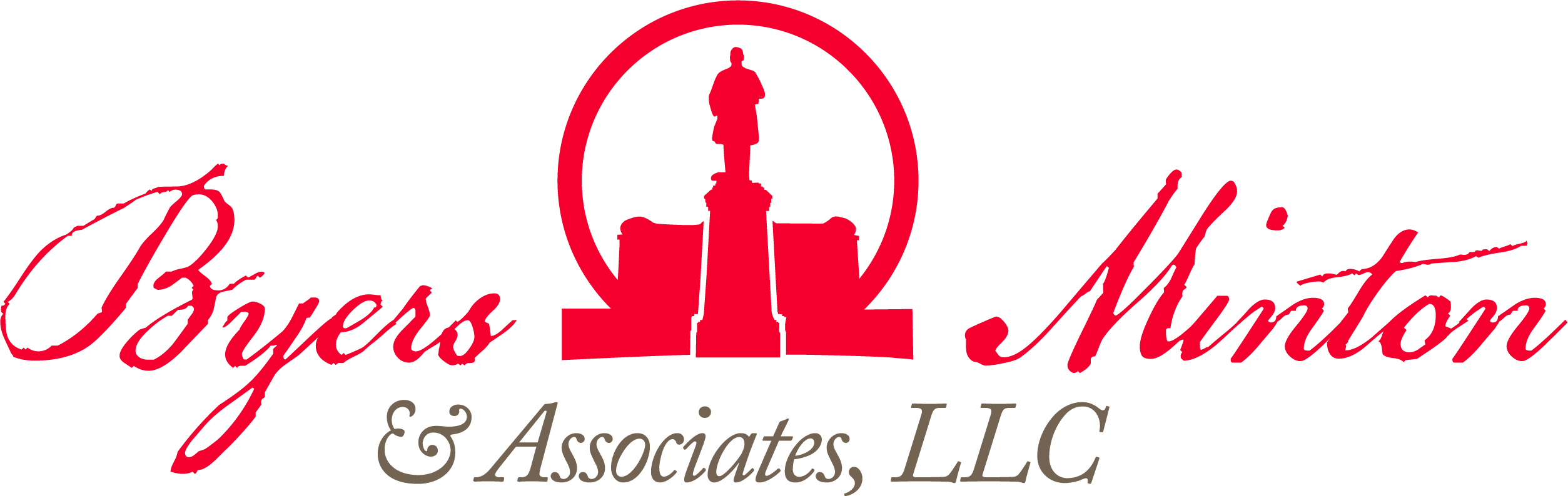

THIs week

at the Statehouse

june 25, 2021
CURRENT COVID STATS

Ohio:
- 923,497 confirmed cases
- 59,412 hospitalizations
- 19,912 confirmed fatalities

United States:
- 33.13 million cases
592,776 fatalities

World:
- 171.71 million cases
- 3.69 million fatalities

Senate Passed Legislation
On Thursday, members of the Senate chamber conducted a late session and made changes to a number of priority bills. After informally passing HB 29, a proposal to broaden eligibility for state veterans IDs, earlier in the day, the chamber added measures that would legalize sports gaming, and allow intercollegiate athletes to earn compensation from their name, image or likeness. Following House session, Speaker Cupp expressed doubt that sports gaming would be finalized before June 30 due to a lack of hearings in the chamber. Senate President Huffman said that the NIL legislation and electronic bingo provisions from the gaming bill could be inserted into the state operating budget if needed, but that broader gaming provisions are unlikely to end up in the spending outline.
NEXT WEEK’S SCHEDULE
Monday:

Tuesday:
- House Session (1 pm)
- Senate Session (1:30 pm)

Wednesday:
- House Session (1 pm)

Thursday:
- House Session (1 pm)

Friday:
Senate Moves to Pay Off Unemployment Debt
On Tuesday, legislators moved to implement Governor Mike DeWine’s plan to eliminate Ohio’s unemployment loan from the federal government. Senator Jay Hottinger offered an amendment to remove the original contents of HB 168, the House’s version of a business grants measure previously enacted through SB 109, and replace it with language that directs the Department of Job and Family Services to certify and retire the debt funding federal COVID-19 relief dollars. The total state borrowing is expected to amount to between $1.47-$1.6 billion, and without action, would begin to accrue interest in September. The decision received praise from the Ohio Chamber of Commerce, and was passed by the Senate on Thursday
Vaccine Language Added to Relief Funding Bill
SB 111, which appropriates $422 million in American Rescue Plan Act dollars to local governments, picked up an amendment on the House floor that would prevent public or private entities from requiring a vaccine that has not been approved by the FDA, and prohibits discrimination based on whether an individual has received a non-FDA approved vaccine.

Bill Introductions
HB 355 - Pregnancy (Boggs, K., Hicks-Hudson, P.): To authorize a pregnant minor to consent to receive health care to maintain or improve her life or the life of the unborn child she is carrying.

HB 356 - Drugs (Loychik, M., Bird, A.): Regards a proposal to reduce the abuse of prescription opioids, to establish addiction treatment facilities, to increase penalties for drug trafficking violations, to modify penalties for drug possession, to require an offender convicted of a drug possession or drug trafficking offense involving certain drugs to be subject to ten years of post-release control, to allow a criminal defendant who has a severe substance use disorder involving certain drugs to be confined by a state detoxification provider while awaiting trial, to create restitution work programs, and to make an appropriation.

HB 357 - Homestead Exemption (Stephens, J., LaRe, J.): To index the homestead exemption amounts to inflation.

HB 358 - Gifts (Lanese, L., Manning, G.): To change the minimum dollar amount of a gift required to be reported, and to require that reporting be done according to a dollar amount range, under the Ohio Ethics Law.

SB 200 - Education (Brenner, A., Fedor, T.): To permit students who were enrolled in 12th grade during the 2020-2021 school year to re-enroll in that grade in the 2021-2022 school year and to declare an emergency.

SB 201 - Date Designation (Huffman, S.): To designate January 22 as the "Day of Tears" and to repeal section 5.53 of the Revised Code, which designates the "Day of Tears," when the U.S. Supreme Court overturns Roe v. Wade.

SB 202 - Parenting (Hackett, B., Antonio, N.): To generally prohibit a person's disability from being used to deny or limit custody, parenting time, visitation, adoption, or service as a guardian or foster caregiver, regarding a minor.

SB 203 - Impaired Driving (Manning, N.): To change the laws pertaining to operating a vehicle or watercraft while under the influence of marihuana and the admissibility of evidence regarding the testing of a person's whole blood, blood serum or plasma, urine, breath, or other bodily substance for purposes of OVI statutes.

