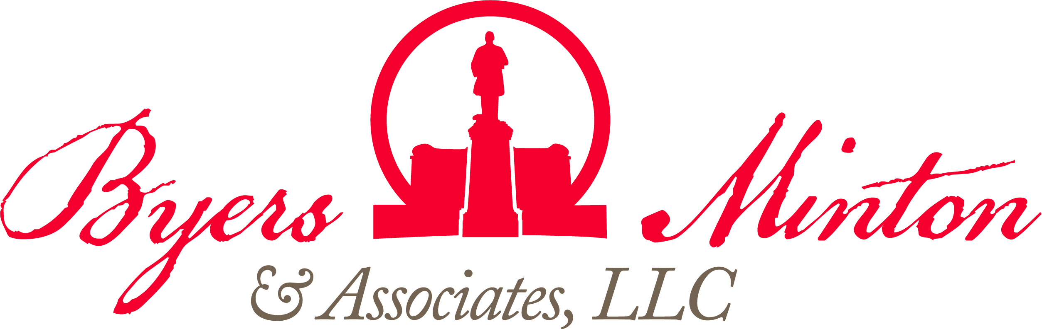

THIs week

at the Statehouse

july 2, 2021

Budget Update
CURRENT COVID STATS

Ohio:
- 923,497 confirmed cases
- 59,412 hospitalizations
- 19,912 confirmed fatalities

United States:
- 33.13 million cases
592,776 fatalities

World:
- 171.71 million cases
- 3.69 million fatalities

On Monday afternoon, the conference committee on HB 110 voted unanimously on its compromised report that included a new school funding system and a massive personal income tax cut. That evening, the Senate voted 32-1 to approve the report, and the House voted 82-13. The bill was signed by the Governor following his 14 line item vetoes, which included vacating COVID-19 violation refunds, Medicaid managed care procurement, College Credit Plus program changes, and more (the Governor’s veto message can be viewed here). The budget includes $74.1 billion in General Revenue Fund appropriations and $161.9 billion in all funds appropriations for Fiscal Years 2022 and 2023.
Wind, Solar Legislation
NEXT WEEK’S SCHEDULE

Monday:

Tuesday:

Wednesday:

Thursday:

Friday:
Wind and solar siting legislation, SB 52, was passed by both chambers after receiving a final round of amendments earlier in the day from the House Public Utilties Committee. The legislation, in part, allows county commissioners to approve a project via a lack of action or to adopt a resolution rejecting/limiting the footprint of the project, permits local officials to adopt a resolution subject to referendum to designate a restricted area or block any material amendment to an existing facility, and creates to ad-hoc seats to the Ohio Power Siting Board to represent county commissioners and township trustees. The bill passed the House with a 52-43 vote, and the Senate with a 21-12 vote. The measure now moves to Governor DeWine for signature, where many groups are encouraging a veto of the legislation.
State Superintendent Retiring
Following three decades of public service, State Superintendent of Public Instruction Paolo DeMaria announced that he will retire on September 24th of this year. Formerly the director of the Office of Budget and Management, DeMaria has served in this role since 2016.

Bill Introductions
SB 204 - Counseling Compact (Roegner, K.): To enter into the Counseling Compact.

SB 205 - Month Designation (Thomas, C.): To designate June as "Gun Violence Awareness Month."

SB 206 - Art & Music Therapists (Yuko, K., Brenner, A.): To license and regulate art therapists and music therapists.

SB 207 - Drug Court (Thomas, C., Wilson, S.): To revise the law governing cases that may be referred to the Hamilton County Drug Court.

HB 361 - Railroads (Hall, T., Miranda, J.): To establish new requirements and increased penalties that apply to a railroad company that unlawfully blocks a railroad crossing.

HB 362 - Law Enforcement (Ingram, C.): To require training on emotional intelligence for peace officers.

HB 363 - Mental Health (Miller, A., Smith, M.): To plans for comprehensive counseling and supportive mental health services in response to disasters, emergencies, and other adverse events.

HR 90 - Member Appointment (Cupp, B.): Relative to the election of Kevin D. Miller to fill the vacancy in the membership of the House of Representatives created by the expulsion of Larry Householder of the 72nd House District.

HB 364 - Waterworks Infrastructure Improvement (Patton, T.): To make changes to the application process for the waterworks infrastructure improvement surcharge.

HB 365 - Water Quality (Lightbody, M., Russo, A.): To require the Director of Environmental Protection to adopt rules establishing maximum allowable contaminant levels in drinking water and water quality standards for certain contaminants.

HB 366 - Cookie Designation (Miranda, J., Kelly, B.): To designate the sugar cookie as the official cookie of Ohio.

HB 367 - Law Enforcement (Jarrells, D.): Regards the use of body-worn cameras and dashboard cameras by peace officers, the use of excessive force by peace officers, and the public release of body-worn camera or dashboard camera recordings when there is an allegation of peace officer misconduct.

HB 368 - College Credit Plus (Bird, A., Pavliga, G.): To permit school districts and schools to establish their own policies for weighted grade averages of courses completed through the College Credit Plus program.

